PROCEDURE OF STUDENT AIMES PAYMENT
- STUDENT WILL CLICK ON THE LINK http://cloud.hijlicollege.ac.in/StudentPortal/Login.aspx .
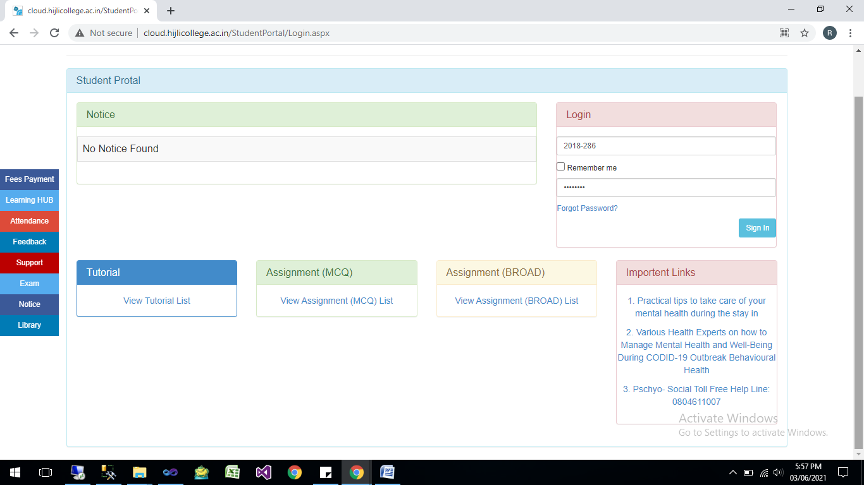

- AFTER FILLING UP STUDENTID AND PASSWORD,CLICK ON SIGN IN BUTTON.
- CLICK ON PAY FEES ONLINE.
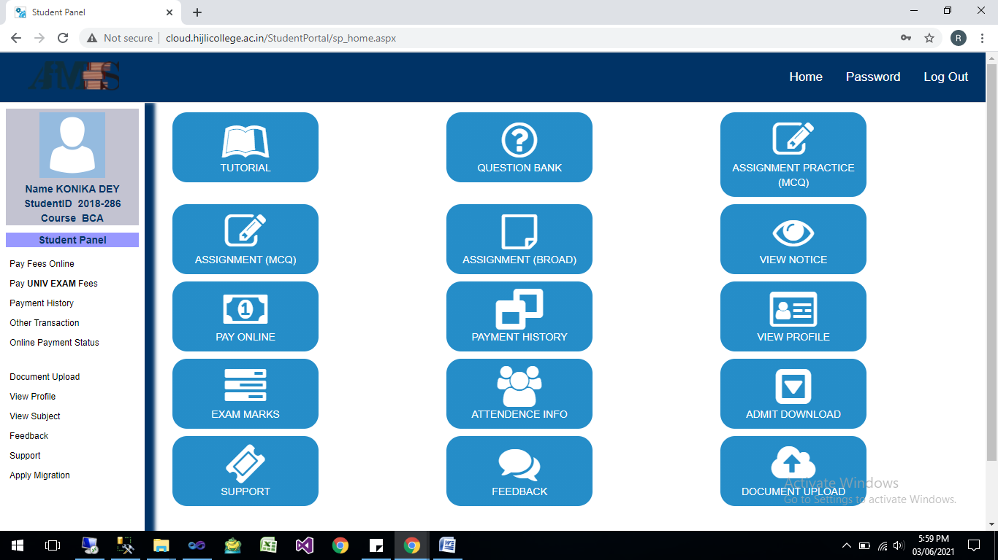
- CHOOSE YOUR SEMESTER FROM DROPDOWN IN WHICH SEM STUDENT WANT TO PAY FOR, AND CLICK ON CONTINUE BUTTON,AND CHECK ON Tick to Confirm before payment .
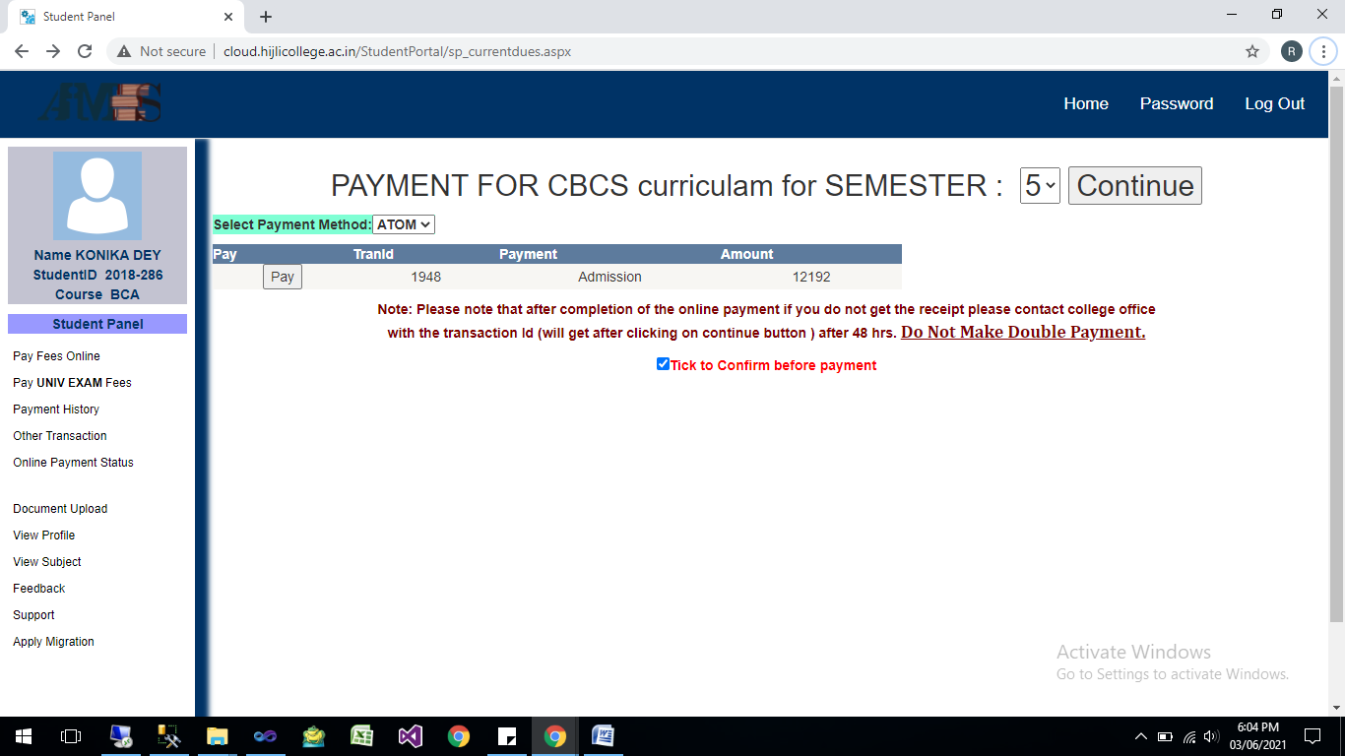
THEN CLICK ON PAY BUTTON TO PROCEED.
- You will be redirected to payment gateway page, where you have to put your credential to Pay your fees.
